38.45: a) 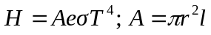
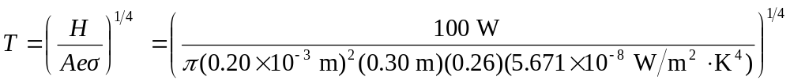
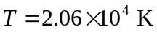
b)
Much of the emitted radiation is in the ultraviolet.

